NEXTAG COMPANY

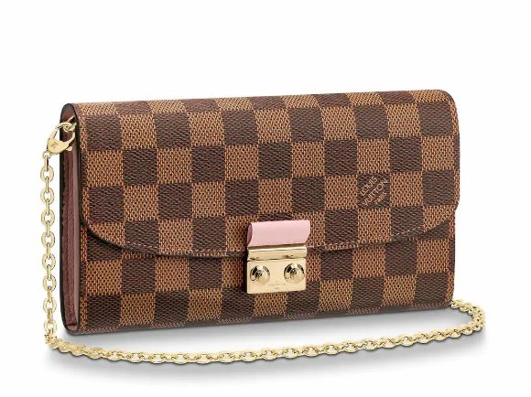LOUIS VUITTON - LOCKME II WALLET

##### **Detail**

Echoing the stylish, casual design of the Lockme II handbag, this wallet in soft calf leather is embellished with a feminine braided detail that subtly references Louis Vuitton's tradition of craftsmanship. Secured with a distinctive LV initials clasp, its spacious interior boasts a variety of pockets and compartments.

• 12 card slots

• 1 patch pocket

• 1 large flat pocket

• Silver color metallic pieces

• 19.5 x 10.0 x 2.0 cm (Length x Height x Width)

##### **CARE & COMPOSITION**

* leather
* imported